For our project, we wanted to create a fighting game that has never been made before. Knowing that the most action-packed **anime**, “Attack on Titan”, is coming to an end, we decided to develop a fighting game dedicated to its characters. This show has captured audiences around the world and has gone viral throughout the internet – even reaching our team. This show was the main inspiration for the theme of our game and has given many ideas for character design and character movements. We also wanted to create something that would never get boring and allow people to play with their friends and family. This motivated and inspired us to create a fighting game where you can go head-on against your friends and with the different characters, and their unique moves, make a game people would keep playing.

Today, people are looking for a game with a fast-paced, competitive **1v1** format that involves hand-eye coordination and requires players to try and predict their opponent's moves.[1] This is the major problem with every fighting game and if one does not meet these criteria, then it can get very boring and repetitive. Another key aspect people are looking for in a fighting game is a good community. People look forward to having a friendly and engaging community for a game where people can connect and compete with each other.[2] For our game, there is a large community of people who have watched and loved “Attack on Titan”, so creating a game based on the show’s characters would draw in a huge fan base – giving our game a community of players. Also, with our game having many unique characters with certain unique moves, players will never get bored and constantly play against each other using different character combinations. Finally, people seem to lean towards playing on the **PC** when doing fighting games such as Fortnite, LeageofLegends, and World of Tanks (Figure 1). Therefore, we see that programming a fighting game meant for the PC would be the best option.

So far, game studios have tried to solve the desires of the people by trying to create games that meet their preferences. According to **IGN**, the top ten best fighter games have multiplayer content, many unique moves and **combos**, and the ability to choose your characters.[3] With a variety of games that provide such content, the gaming community will never get bored and will always discover new techniques and strategies for each game – making these games refreshing and endlessly entertaining. And, as more games come out, older characters no longer change in play style but to compensate they add new characters and **DLC**sto always keep the community entertained – as shown with every new release (Figure 2).

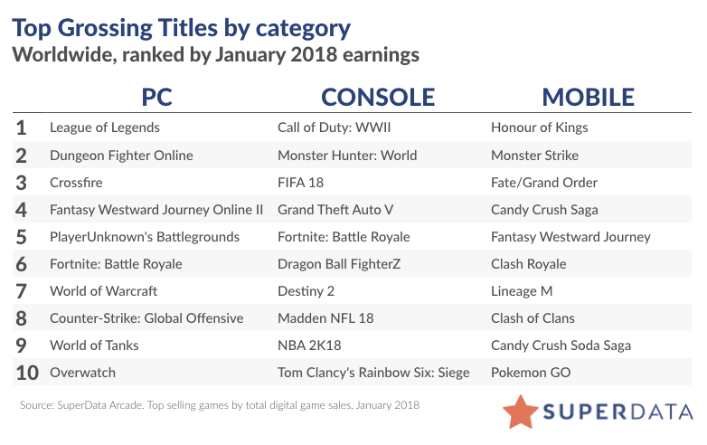

1.Nirolak, “Superdata estimates Dragon Ball FighterZ had largest digital sales for a fighting game launch ever,” *ResetEra*, 27-Feb-2018. [Online]. Available: https://www.resetera.com/threads/superdata-estimates-dragon-ball-fighterz-had-largest-digital-sales-for-a-fighting-game-launch-ever.26106/. [Accessed: 26-Feb-2023].

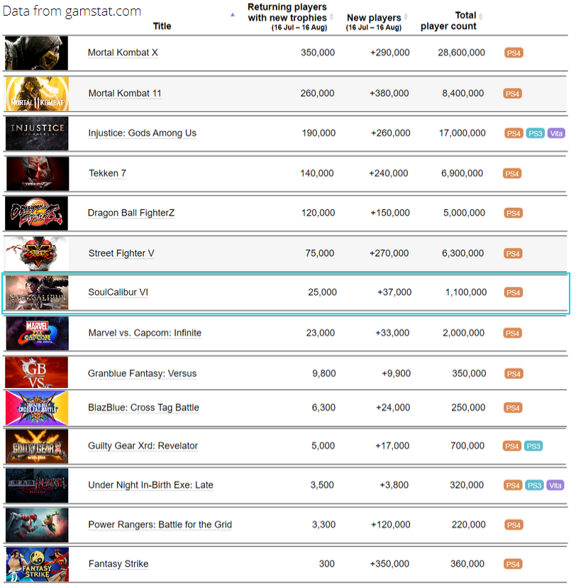

2.“R/fighters - playstation fighting game stats (partial sampling),” *reddit*. [Online]. Available: https://www.reddit.com/r/Fighters/comments/iegaxj/playstation_fighting_game_stats_partial_sampling/. [Accessed: 26-Feb-2023].

1. “What is the psychology of a person who loves fighting games ... - quora.” [Online]. Available: https://www.quora.com/What-is-the-psychology-of-a-person-who-loves-fighting-games. [Accessed: 27-Feb-2023].
2. “R/fighters - what do you look for in a fighting game?,” *reddit*. [Online]. Available: https://www.reddit.com/r/Fighters/comments/i2rami/what_do_you_look_for_in_a_fighting_game/. [Accessed: 26-Feb-2023].
3. I. G. N. Staff, “The 10 best fighting games,” *IGN*, 10-Aug-2022. [Online]. Available: https://www.ign.com/articles/the-10-best-fighting-games. [Accessed: 26-Feb-2023].

1. [Game Characteristics](https://www.quora.com/What-is-the-psychology-of-a-person-who-loves-fighting-games#:~:text=Fighting%20games%20are%20appealing%20because,these%20elements%20to%20an%20extent.)
2. [reddit](https://www.reddit.com/r/Fighters/comments/i2rami/what_do_you_look_for_in_a_fighting_game/)
3. [IGN](https://www.ign.com/articles/the-10-best-fighting-games)